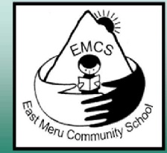
East Meru Community School – Tanzania
Pupil Sponsorship Information
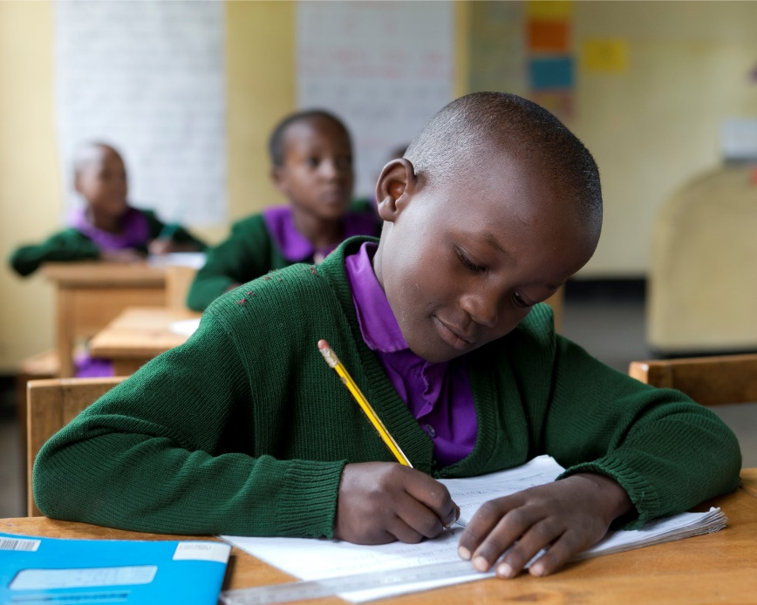
Just £20, EUR25, AUS$30, $US25 per month
Monthly sponsorship payments are used to provide:
- full uniform including shoes, two shirts or dresses, two pairs of trousers and one sweater
- the teacher’s salary
- teaching materials
- classroom stationery
- daily tea and a healthy lunch
We have small classes, a maximum of 30, and we aim to provide a conducive environment for learning with good teaching resources and well qualified teachers who share the caring, nurturing ethos of the school.
We are a school which is rooted in the community and we only select children from the local area. We have no plans to provide any kind of boarding facilities because we firmly in the importance of having our children return home at the end of each day – to remain an important part of their families and their community as a whole.
For more information and FAQs, see the following page.
If you would like to become part of our East Meru Community School family and sponsor one of our children, please email info@eastmerucommunityschool.org. We would be so happy to hear from you!
East Meru Community School is an English Medium Primary School located in Maruvango, a remote rural village in Northern Tanzania.
Children, of all abilities, are recruited from the most needy families in the local community and all their needs are provided for through our sponsorship programme.
…… because every child deserves the chance to learn.
How can I be sure that your project is a legitimate organisation? East Meru Community School is owned by Tikundane, a Tanzanian registered NGO Registration No. 00004359. We are also recognised by the Charity Commission in the UK and have an affiliated charity known as Friends of East Meru Community School Registration No. 1168456. The school is also registered with the Tanzanian Ministry of Education and Vocational Training Registration No AR.03/7/018.
How can I be sure that my sponsorship funds are wisely used? The school is managed by Founder Director Ian Horne, a permanent resident of Tanzania, and Ian oversees all purchasing. All accounts are available for scrutiny from the Tikundane NGO and an Annual Report of funds channelled through the UK is submitted to the UK charity commission.
How can I be sure that my funds are going directly to the child’s education? Unlike many other NGOs we keep all of our administrative costs to a minimum because we do not operate from a Head Office outside of Tanzania and all of the administrative work is carried out by the Director or by volunteers who receive no payment.
Is there a recruitment policy? Yes – we recruit children from the most disadvantaged backgrounds, within a reasonable walking distance of the school. We recruit children of ALL abilities, because we believe that every child deserves to learn, and therefore we do not have an Entry test. In the spirit of fairness, we are only able to recruit one child per family.
What is Pupil Sponsorship? Sponsorship is either an annual or a monthly payment towards the educational costs of an individual child.
Who can become a Pupil Sponsor? Anyone who is genuinely interested in supporting one of our pupils can become a sponsor. We deliberately keep the payments as low as possible to enable people from all walks of life to become part of our sponsor family. We are happy to accept individuals, families, groups, churches, clubs and organisations, schools etc as sponsors.
How do I become a Pupil Sponsor? In the first instance please contact ianmhorne@yahoo.co.uk and then you will receive an email explaining the next steps.
How much is Pupil Sponsorship? In 2016/7 sponsorship payments were set at £20, EUR25, US$25 or AUS$30.
What happens if I wish to make a one off payment rather than a monthly donation? We are happy to accept monthly or annual payments, and individual sponsors can decide what works best for them.
How do I make these payments? The instructions for payments are provided in a separate document – one for UK sponsors and another for non-UK sponsors. UK sponsorship is being channelled through our online BT MyDonate fundraising platform and non UK sponsors are directed to our Country Representatives in the Netherlands, Australia or New Zealand.
What happens if I’m not from any of these countries? No problem! When you make your initial contact with Ian Horne, you will receive an email explaining what to do next.
When can I start my sponsorship? We are always looking for new sponsors, and so please feel free to make enquiries at any time of year. We particularly need sponsors for the start of our new Academic year (in January) but occasionally, we have existing pupils who need a sponsor. If all of our pupils are sponsored at the time of your enquiry you will be invited to donate to one of our other appeals, such as our Food programme, until such time as a sponsor pupil becomes available.
What can I expect in return for my sponsorship? You will receive a Pupil Profile containing photographs and details of the child’s background, plus a school report, a Thank You drawing, and updated photograph at the end of each term. Of course, you will also have the satisfaction that you have helped to change the life of a child and their family!

